### Slice form Christmas Ball Ornament with a Snowflake Inside

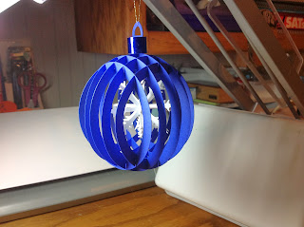

This slice form Christmas ball ornament has evolved from my first globe slice form which was a solid sphere. It is essentially the same design with the center cut out. When making this ornament, I would recommend using good quality cardstock. The slits need to be exact as this will cause the slices to insert correctly into one another and look evenly spaced.

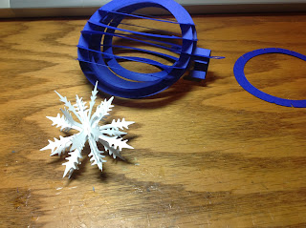

Make the Slice form Ball by starting with the center and going outward.

Make the Snowflake by bending the two pieces with the perforated edges and inserting it into the piece without the perforations and a little slit in the center.

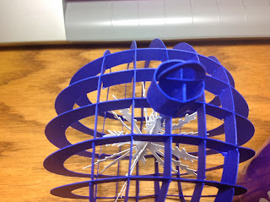

Glue the snowflake into the center of the Christmas Ball by attaching the two slits together.

Make the hangar by wrapping the rectangular piece into a circle as shown above.

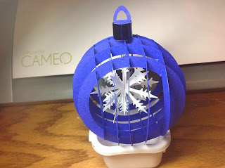

Add the rest of the slices to complete the Christmas Ball.

I added an additional rectangular piece of shiny paper around the hangar for interest.



Another Christmas Ornament to add to my collection... Lovely!